

Lumoral Treatment   – User manual

© 2022 Koite Health Ltd., Espoo, Finland. All rights reserved. Reproduction of any part of this document without the written permission of Koite Health Ltd. is prohibited.

Koite Health Ltd. reserves the right to make changes to all specifications herein at any time, without notice or obligation. All technical information is provided for guidance purposes only.

Koite Health Ltd.

Kutojantie 2C

02630 Espoo

Finland

Email: [info@koitehealth.com](mailto:info@koitehealth.com)

Website: [www.lumoral.com](http://www.lumoral.com)

This user manual is intended for the following Koite Health Ltd. device: Lumoral treatment, Version 5. Manual approved for use: 2022-04-01. Version number 02-01-01-05-EN.

Koite, Lumoral, and Lumorinse are trademarks of Koite Health Ltd.

Table of contents

[1 Introduction 4](#_Toc99703303)

[1.1 General information 4](#_Toc99703304)

[1.2 About the Lumoral Treatment device 4](#_Toc99703305)

[2 Safety information 6](#_Toc99703306)

[2.1 Warnings 6](#_Toc99703307)

[2.2 Restrictions for use 7](#_Toc99703308)

[3 Effects of use 8](#_Toc99703309)

[4 Instructions for use 9](#_Toc99703310)

[4.1 Setting up and using the Lumoral device 9](#_Toc99703311)

[4.2 Device signalling 10](#_Toc99703312)

[4.3 Charging and handling the power bank 11](#_Toc99703313)

[5 Device operation and maintenance 12](#_Toc99703314)

[5.1 Device operation 12](#_Toc99703315)

[5.2 Storing 12](#_Toc99703316)

[5.3 Cleaning 12](#_Toc99703317)

[5.4 Service 13](#_Toc99703318)

[5.5 Calibration 13](#_Toc99703319)

[5.6 Disposal 13](#_Toc99703320)

[6 Symbols used 14](#_Toc99703321)

[7 Compliance with safety directives and standards 15](#_Toc99703322)

[8 Technical specifications 16](#_Toc99703323)

[9 Electromagnetic emission declaration 16](#_Toc99703324)

[10 Warranty 19](#_Toc99703325)

[11 Product support 19](#_Toc99703326)

# Introduction

## General information

This document is the user manual for both healthcare professionals and consumers using the Lumoral Treatment device.

* Read this manual carefully before using the device and strictly follow all instructions.
* Lumoral Treatment device is an antibacterial home- or clinic-use medical device for the treatment of periodontitis and prevention of progression of periodontitis and caries. The Lumoral Treatment device is used in conjunction with mechanical dental cleaning (brushing and flossing teeth).
* Lumoral Treatment device is intended to be used only with Lumorinse mouthrinse. Each Lumorinse tablet contains 7 mg of the active substance indocyanine green. When dissolved in water, Lumorinse soluble tablet forms a mouthrinse. The mouthrinse is then swished in the mouth and it adheres to the plaque.
* Lumoral Treatment device produces both near-infrared light and antibacterial blue light. The interaction of Lumorinse with Lumoral treatment -device's near-infrared light produces a bactericidal effect on plaque. The effect is enhanced by the simultaneous antibacterial blue light.
* The Lumoral Treatment device is intended for use by healthcare professionals or for personal use. The device can be used with assistance or alone. For more information, please contact Koite Health by email at [info@koitehealth.com](mailto:info@koitehealth.com).

* After opening the package, make sure that there are no external defects or damage to the device. If you suspect that something is faulty with your device, contact your dealer.
* Store the device out of the reach of children and pets. The device can be used by small children only under the supervision of an adult.
* In case you encounter any serious incident related to the to the Lumoral or Lumorinse products, please report the incident to Koite Health [safety@koitehealth.com](mailto:safety@koitehealth.com) and your local competent authority.

Please contact Koite Health or the reseller if you need assistance in setting up, using, or maintaining the Lumoral treatment -device. Report any unexpected events related to the use of the device to the reseller or customer support at [info@koitehealth.com](mailto:info@koitehealth.com).

## About the Lumoral Treatment device

Lumoral Treatment device is an antibacterial home- or clinic-use device for the treatment of periodontitis and prevention of progression of periodontitis and caries. Lumoral Treatment device is used to complement mechanical dental cleaning (brushing teeth and flossing).

The device can be used at home or any health care environment, including dental clinics, when the health care provider takes appropriate precautions to prevent bacterial contamination between patients.

Lumoral Treatment dual-light activator should be used together with light-activated dental plaque-adhering Lumorinse mouthrinse.

The device is intended for regular use. For the treatment of periodontal disease, the frequency of the use is performed according to the dental professional’s instructions.

The suggested treatment protocol for periodontal disease is daily use. For the prevention of oral disease, a minimum twice-a-week use is recommended.

The Lumoral Treatment Starter Kit package includes

* A Lumoral Treatment device
* A Power bank (USB type C) with a power cord
* Lumorinse tablets
* A measuring cup
* The user manual

Lumoral Treatment device is intended to be powered by the external power unit as specified below:

* Capacity: 9000-15000(mAh)
* Port Type: Type C USB Port
* Output: 12V 1.5A
* Input: 5V 2.4A

3

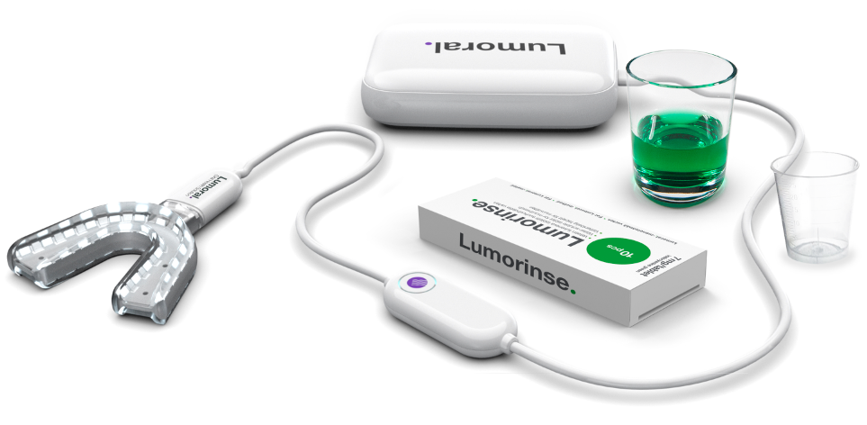

2

5

1

4

Figure 1. *The mouthpiece (1) is joined with the control unit (ON/OFF button)(2) and the power unit (3). Lumorinse tablets (4). The glass (not included in the pack) contains a dose of Lumorinse dissolved in water.* *Measuring cup* (5).

Lumoral treatment is started by rinsing the mouth with the Lumorinse mouthrinse. Rinsing the mouth causes the Lumorinse active substance indocyanine green to adhere to dental plaque. The antibacterial effect is activated with the Lumoral Treatment -dual-light applicator.

The Lumoral Treatment -device, when used together with Lumorinse, kills periodontal disease and cavity-causing *pathogenic oral bacteria* from dental plaque. The effect is targeted at the dental plaque. The targeted approach helps to keep the overall oral flora diverse in the mouth.

The Lumoral Treatment device is safe to use, and there are no known side effects when the instructions for use are followed. The light emitted by the device is visible light and near-infrared light wavelengths. The device is compliant with the IEC 62471 Photobiological safety of lamps and lamp system.

The mechanism of action is initiated when the photosensitizer (Lumorinse) absorbs a photon and undergoes an energy transfer reaction. The absorbed energy is released in the form of singlet oxygen (photodynamic process) and localized heat generation (photothermal process). Dental pathogenic bacteria are especially vulnerable to photodynamic and photothermal effects.

**The device will generate heat, which is a part of the treatment effect.** The user will feel warmth in the teeth and gums during treatment. If the treatment is uncomfortable, the treatment can be performed in two parts with a break of one or two minutes in between.

# Safety information

## Warnings



This symbol indicates safety information about the hazards of handling and using the product.

The following precautions must be taken to reduce side effects when using the Lumoral treatment -device.

* Use the device only according to the instructions provided in this user manual. The manufacturer is not responsible for any damage or consequences that may result from non-intended use or misuse of the device.
* Avoid looking directly into the light source of the device.
* Do not perform any repair or maintenance activity other than what is specified in this manual.

All other repair and maintenance actions must be performed by the manufacturer or authorized service agent. For more information about maintenance and service, see section 5 of this manual (Device operation and maintenance).

* Do not modify or open the device, as the safety of the device cannot be guaranteed after such actions.
* Do not use the device near flammable materials, including flammable anaesthetics.
* Do not use the device in environments with strong magnetic fields or with high levels of electromagnetic interference.
* Do not use the device next to electromagnetically sensitive equipment.
* Do not immerse the control unit in any liquid. The control unit and the power bank contain sensitive electronic components that can be damaged by contact with liquids. The mouthpiece can be immersed in water.
* Do not connect any other power sources to the device than those specified in these instructions. We recommend using the power source that comes with the device.
* Ensure that use and storage are carried out under the conditions specified in Section 8 of this manual (Technical specifications).
* Ensure that the cables/cords and their protective parts are in perfect working condition before use.
* Lumorinse is safe to use and is not absorbed in the digestive tract. However, we recommend spitting it out after swishing in mouth and avoid swallowing it.
* For safety reasons, do not drop, short circuit, or use the power bank at high temperatures.
* If the power supply swells or changes shape, stop using it.
* Keep the power bank out of the reach of small children. The power supply is intended for adult use.
* Failure to follow the instructions for the power bank may result in fire or possible injury.



**Note!** The device must be used only with Lumorinse products.



**Note!** Consult this instruction for use and the Lumorinse package markings concerning indication, contraindications and effects before using the Lumorinse product.

## Restrictions for use

Consult your doctor before using the device if you have oral candidiasis (thrush) or history of near infrared or blue light sensitivity.

Depending on the shape of the dental arch, the mouthpiece might not fit optimally. It is important to note that the mouthpiece is applying light, and perfect fit is not required for the treatment to be effective.

Children aged four and above should only use the device under adult supervision. A dentist consultation is recommended before using the device with children aged three and below.

In case of any suspected adverse events, report to [safety@koitehealth.com](mailto:safety@koitehealth.com).

# Effects of use

The Lumoral Treatment device is intended to be used in addition to regular daily dental hygiene: toothbrushing a minimum of 2 times a day with toothpaste and daily interdental cleaning (tooth flossing).

For optimal results, use Lumoral treatment as recommended by the dental professional. The treatment can be used daily up to three times a day. The minimum recommended use is twice a week, for 10 minutes at a time.

The Lumoral treatment -device, when used together with Lumorinse, kills cavity-causing and periodontitis-causing bacteria effectively in the dental biofilm. The effect is selective; it is targeted at the dental plaque. The overall oral flora stays diverse.

Regular use treats periodontal diseases, and the device can also be used for the preventing of periodontal diseases, caries, oral mucositis and dental plaque formation.

Under the supervision of a doctor or a dentist, it is possible to use a Lumoral Treatment device together with Chlorhexidine mouthwash for an increased bactericidal effect if needed. However, regular use of Chlorhexidine is not recommended. Chlorhexidine does not replace the use of Lumoral Treatment.

The Lumoral treatment device is safe to use, and there are no side effects when the instructions for appropriate use are followed. The light emitted by the device is visible light and near-infrared light wavelengths.

The following sensations may occur during use:

* Lumoral Treatment device produces heat. The user will feel warmth in the teeth and gums during treatment.
* Device increases the blood circulation in the tissues locally. Heat and near-infrared light may enlarge the blood vessels (vasodilation), which may feel like a feeling of weight or pulsing in the gums.
* Increased saliva production may temporarily be experienced. Saliva has an important oral health-promoting function because it moisturizes, cleanses and protects the teeth, oral mucous membranes, gums and throat.

# Instructions for use

## Setting up and using the Lumoral device

Follow these instructions (refer to the images above in Figure 1):

1. Unpack and inspect the device and accessories from the package.
2. Measure 30 ml of water into the measuring cup and pour it into a glass. 30 ml equals about 2 tablespoons of water.
3. Put one Lumorinse tablet (4) into the water. Let it dissolve for about 30 seconds or until fully dissolved.

Note! Wait until the tablet is dissolved.

Note! The active substance is photosensitive when dissolved in water. For the active ingredient to function properly, the mouthwash should be used immediately after dissolving the tablet in water.

1. Swish the mouthrinse for about **60** seconds, and then spit it out. Do not rinse your mouth with water.
2. Position the mouthpiece gently (1) in place between your upper and lower dental arch (teeth).
3. Attach the Type-C connector of the mouthpiece (1) to the power bank (3).

Note! If the power bank does not supply power to Lumoral. Press twice with quick repeats the power bank button on the side of the power bank. The power bank LEDs should then turn off. Then press the power bank side button again to turn LEDs on, and Lumoral is operational.

1. Press the ON/OFF button on the cord (2) to start the device.

Note! Put the device to your mouth first.

1. Keep the mouthpiece in place for 10 minutes until the light goes off automatically.
2. The device can also be turned OFF by pressing the ON/OFF button (2) on the control unit.
3. Clean the device after use with warm water and mild dish washing detergent. Let it dry.
4. Brush your teeth for 2 minutes with toothpaste.
5. Store the device in a safe place so that it does not fall and so that the cords/cables are not damaged.

Note! Do not bite the Lumoral mouthpiece. If the surface of the mouthpiece is damaged, the device cannot be used.

Note! The thermal effect is part of the antibacterial effect. Both the device itself and the photothermal reaction produce heat. If the device temperature is over 50°C, the temperature safety function turns off the device automatically. If you have concerns about the temperature being too high, contact Koite Health [info@koitehealth.com](mailto:info@koitehealth.com) or the reseller.

Note! Lumorinse releases part of the light activation energy as heat. Therefore, the treatment feels warm or hot in some cases when there is a high amount of dental plaque on the tooth surface. This is because dental plaque uptakes the Lumorinse inside in higher concentrations and causes local heat release. This is part of the treatment effect. If there is discomfort during treatment, we advise keeping a short break or brushing teeth before treatment to limit dental plaque quantity at the treatment area.

Figure 2. Lumoral Treatment mouthpiece in use.

## Device signalling

The Lumoral treatment device has five different states that are indicated by a signalling light in the control unit (Figure 1, item 2):

1. Turned OFF – The power button has no light on.
2. Operating – The power button light is on
3. Wrong power input – The light blinks 5 times
4. The temperature threshold is exceeded – The device shuts down, and the signal light blinks 10 times.
5. The device has not cooled down enough – The device will not turn on, and the signal light blinks 3 times.

Note! If the temperature threshold is exceeded repeatedly, please contact customer support at [info@koitehealth.com](mailto:info@koitehealth.com).

## Charging and handling the power bank

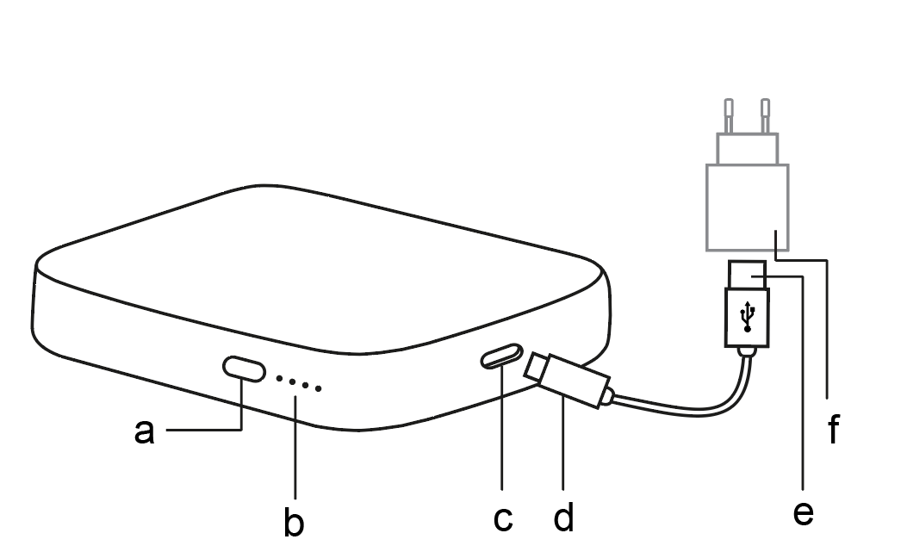

Figure 3. *The power bank. The capacity indicator button (a), the capacity indicator LEDs (b) and the type C port (c). The charger cord with type-C connector (d) and USB type 2.0 connector (e). Example of a power adapter (f) (not included in the package).*

Charging the power bank:   
Connect the charging cable with the type-C USB connector to the power bank. Connect the type 2.0 USB connector to a suitable power adapter with a USB type 2.0 output. You can use, for example, the power adaptor of your mobile phone charger.

To check the charge level of the power bank, press the indicator button once.

A single light flashing indicates the need for charging. The capacity indicator LED lights show the approximate power bank capacity.

Do not press the power bank switch before connecting to the Lumoral device.

When you press the indicator button, the power bank measures the charge status, cutting power from Lumoral. To stop measuring, press the indicator button twice. After reconnecting the  
cord, the device is ready for use again.

|  |  |  |  |  |  |
| --- | --- | --- | --- | --- | --- |
| Capacity indicator LEDs | 0 on | 1 on | 2 on | 3 on | 4 on |
| Capacity | Fully discharged | <25% | 25-50% | 50-75% | 75-100% |

To handle and charge the power supply, follow these precautions:

Note! Do not use or connect the mouthpiece to the power bank while the power bank is charging.

Note! Do not connect the mouthpiece to any USB-C output which is powered directly from the electric grid.



Note! For safety reasons, do not drop the power supply, cause a short circuit in it, hit it with hard objects, disassemble it yourself or use it at high temperatures.



Note! If the power supply swells or changes shape, stop using it immediately.



Note! Keep the power bank out of the reach of children. The power bank is for adults only.

Note! Follow the instructions of this user manual. Failure to do so may result in fire or damage to the unit.

# Device operation and maintenance

## Device operation

After the Lumoral Treatment mouthpiece has been connected to the power bank, the device operation can be started by pressing the power button. The device stays on for 10 minutes to complete the treatment protocol. The device automatically turns itself off.

## Storing

Store the device in a location where it is not exposed to excessive dust. Dust accumulation can prevent the device from operating reliably. More detailed information about storage conditions can be found in section 8 (Technical specifications).

Protect the Lumorinse tablets from moisture, heat, light and freezing. The shelf life of the tablets is printed on the Lumorinse package.

## Cleaning

See Figure 1. Turn off the power from the power bank (3) before cleaning the device. Remove the mouthpiece connector from the power bank. The mouthpiece (1) can be rinsed with water or wiped with a damp cloth. If detergent is needed, a mild dishwashing liquid is recommended.

The control unit (2) can be wiped with a damp cloth. The connector plug, control unit or power bank should not be immersed in water.

If necessary, disinfect with mild, non-corrosive substances. Strong acids, bleach, aromatic or chlorine-containing hydrocarbons, spirits, esters, ethers and ketones must not be used, as they can corrode the material.

Note! Do not rinse the control unit with water. If the connector plug is wet, let it dry before connecting it to the power bank.

Note! Avoid looking directly into the light of the Lumoral treatment mouthpiece while the device is on.

## Service

Do not service the device yourself except as described in this manual. If technical maintenance is required, please contact Koite Health customer support via email at [info@koitehealth.com](mailto:info@koitehealth.com).

## Calibration

The device has been initially calibrated at the time of manufacture. If this device is used according to the instructions of use, periodic calibration is not required. If at any time you question the accuracy and functionality of the device, please contact the distributor or manufacturer.

## Disposal

The Koite Health Lumoral treatment device consists of metal, plastic and electronic components. The power bank is a lithium-ion battery. Do not throw away the device or power bank in the mixed household waste at the end of life. They should be disposed of according to the electrical and electronic equipment waste recycling legislation. Deliver the device for recycling to an official collection point for electronic devices. Check with the appropriate recycling organization for local disposal information.

# Symbols used

|  |  |  |  |
| --- | --- | --- | --- |
| General symbols | | | |
| Symbol | Explanation | Symbol | Explanation |
| |  | | --- | |  | | Consult instructions for use |  | General warning sign |
| |  | | --- | |  | | Follow instructions for use |  | Manufacturer |
| |  | | --- | |  | | Serial number |  | Type BF device |
| |  | | --- | |  | | Batch code |  | Do not dispose of the product with household waste. Deliver it to an appropriate recycling point. |
| **IPX7** | IP Classification.  Protected against short periods of immersion in water. | C:\Users\lassi\AppData\Local\Packages\Microsoft.Office.Desktop_8wekyb3d8bbwe\AC\INetCache\Content.MSO\220AF67E.tmp | Non-ionizing radiation |
| |  |  | | --- | --- | | **0598** | CE-label. The product is compliant with the Medical Device Directive 93/42/EEC. Notified body number underneath. | | |  | Caution |
| 40°C   |  | | --- | | 5°C | | Temperature limit (Storage) | 93%  15%   |  | | --- | |  | | Humidity limitation (Storage) |
| |  | | --- | |  | | Keep dry |  | Do not use if the package is damaged |
|  | Item is a medical device |  |  |
|  | Use-by date |  | Keep away from sunlight |
|  | FCC label. The electromagnetic interference from the device is under limits approved by the US Federal Communications Commission. |  | ROHS label:  The device is compliant with Restriction of Hazardous Substances (RoHS)  Directive 2002/95/EC |
|  | The product is recyclable. |  | Environmentally Friendly Use Period (EFUP) of batteries and devices. 5 indicates the number of years within which a battery or device is unlikely to have an environmental impact. |

# Compliance with safety directives and standards

The Koite Health Lumoral is a CE-marked class IIa medical device. It is compliant with the following directives and standards:

Directive 93/42/EEC – Medical Device Directive

Directive 2011/65/EU – Restriction of Hazardous Substances (RoHS) Directive

Directive 2012/19/EU – Waste Electrical and Electronic Equipment (WEEE) Directive

European Committee for Standards - electrical – EN 60601-1:2006/AMD1:2013, EN 60601-1-2:2015, EN 60601-1-6:2010, EN 60601-1-11:2015

# Technical specifications

|  |  |
| --- | --- |
| **Operating conditions** | |
| Operating temperature | +10 Celsius - +35 Celsius |
| Operating humidity | 15 - 93 % |
| **Storage conditions** | |
| Storage temperature | +5 Celsius - +40 Celsius |
| Storage humidity | 15 - 93 % |
| **Operating system** | |
| Suitable charging power | 5V - 2A |
| Operating voltage | 20 VDC |
| Operating power | 10W |
| Safety class | I |
| Protection class | IP X7 (Mouthpiece) |
| **Performance** | |
| Operating wavelength range | 400 – 850 nm |
| Output light intensity | 100 mW/cm² |
| Maximum on-time | 11 min |
| Minimum off-time | 5 min. or until device has cooled down to ambient temperature. |

# Electromagnetic emission declaration

Lumoral is a medical device and is intended for use in the electromagnetic environment specified below. The end user of the device should ensure that it is used in such an environment. The use of accessories and cables other than those specified may result in increased emissions or decreased immunity of the unit.

|  |  |  |
| --- | --- | --- |
| **Guidance and manufacturer’s declaration - Electromagnetic emissions** | | |
| RF emissions CISPR 11 | Group 1 | The Lumoral device uses radio frequency energy only for internal functions. Therefore, its RF emissions are very low and should not cause harmful interference to electronic devices in the vicinity of the device. |
| RF emissions CISPR 11 | Class B | The Koite Health Lumoral device is suitable for use in all establishments, including domestic establishments and those directly connected to a public low-voltage power supply network that supplies buildings used for domestic purposes. |

|  |  |  |  |  |
| --- | --- | --- | --- | --- |
| **Recommended separation distances between portable and mobile RF communications equipment and the Lumoral device** | | | | |
| The Lumoral device is intended for use in an electromagnetic environment in which radiated RF disturbances are controlled. The customer or the user of the Lumoral device can help prevent electromagnetic interference by maintaining a minimum distance between portable and mobile RF communications equipment (transmitters) and the Lumoral device as recommended below, according to the maximum output power of the communications equipment. | | | |
| **Rated maximum output power of transmitter**  **(W)** | **Separation distance according to frequency of transmitter**  **(m)** | | |
| **150 kHz to 80 MHz $$d=1.2 \sqrt{P}$$** | **80 MHz to 800 MHz $$d=1.2 \sqrt{P}$$** | **800 MHz to 2.5 GHz $$d=1.2 \sqrt{P}$$** |
| 0.01 | 0.12 | 0.12 | 0.23 |
| 0.1 | 0.38 | 0.38 | 0.73 |
| 1 | 1.2 | 1.2 | 2.3 |
| 10 | 3.8 | 3.8 | 7.3 |
| 100 | 12 | 12 | 23 |
| For transmitters rated at a maximum output power not listed above, the recommended separation distance *d* in meters (m) can be estimated using the equation applicable to the frequency of the transmitter, where *p* is the maximum output power rating of the transmitter in watts (W), according to the transmitter manufacturer.  NOTE 1 At 80 MHz and 800 MHz, the separation distance for the higher frequency range applies.  NOTE 2 These guidelines may not apply in all situations. Electromagnetic propagation is affected by absorption and reflection from structures, objects and people. | | | |

|  |  |  |  |
| --- | --- | --- | --- |
| **Guidance and manufacturer’s declaration – electromagnetic immunity** | | | |
| *The Lumoral device is intended for use in the electromagnetic environment specified below. The end user of the device should ensure that it is used in such an environment.* | | | |
| **Immunity test** | **IEC 60601 test level** | **Compliance level** | **Electromagnetic environment guidance** |
| Electrostatic discharge (ESD)  IEC 61000-4-2 | ± 8 kV contact ± 2 kV, ± 4 kV, ± 8 kV, ± 15 kV air | ± 8 kV contact ± 2 kV, ± 4 kV, ± 8 kV, ± 15 kV air | Floors should be wood, concrete, or ceramic tile. If floors are covered with synthetic material, the relative humidity should be at least 30%. |
| Radiated RF  IEC 61000-4-3 | 10 V/m  80 MHz – 2,7 GHZ | 10 V/m  80 MHz – 2,7 GHZ | Portable and mobile RF communications equipment should be used no closer to any part of the Lumoral device, including cables, than the recommended separation distance calculated from the equation applicable to the frequency of the transmitter.  Recommended separation distance:  d = 1.2 √P  d = 1.2 √P 80 MHz to 800 MHz  d = 2.3 √P 800 MHz to 2.5 GHz  where P is the maximum output power rating of the transmitter in watts (W) according to the transmitter manufacturer and d is the recommended separation distance in meters (m).  Field strengths from fixed RF transmitters, as determined by an electromagnetic site survey¹, should be less than the compliance level in each frequency range².  Interference may occur in the vicinity of equipment marked with this symbol:   C:\Users\lassi\AppData\Local\Packages\Microsoft.Office.Desktop_8wekyb3d8bbwe\AC\INetCache\Content.MSO\220AF67E.tmp |
| Power frequency (50/60 Hz) magnetic field IEC 61000-4-8 | 30 A/m | 30 A/m | Power frequency magnetic fields should be at levels characteristic of a typical location in a typical commercial or hospital environment. |
| Electrical fast transient | ± 2 kV, 100Hz repetition frequency |  |  |
| NOTE 1 At 80 MHz and 800 MHz, the separation distance for the higher frequency range applies.  NOTE 2 These guidelines may not apply in all situations. Electromagnetic propagation is affected by absorption and reflection from structures, objects and people. | | | |
| ¹ Field strengths from fixed transmitters, such as base stations for radio (cellular/cordless) telephones and land mobile radios, amateur radio, AM and FM radio broadcasting and TV broadcasting cannot be predicted theoretically with accuracy. To assess the electromagnetic environment due to fixed RF transmitters, an electromagnetic site survey should be considered. If the measured field strength in the location in which the Lumoral device is used exceeds the applicable RF compliance level above, the Lumoral device should be observed to verify normal operation. If abnormal performance is observed, additional measures may be necessary, such as re-orienting or relocating the Lumoral device.  ² Over the frequency range 150 kHz to 80 MHz, field strengths should be less than 3 V/m. | | | |

# Warranty

This warranty is valid in the territory of the European Union. It does not limit the applicability of mandatory legislation in force in the European Union, such as the Consumer Protection Act, to the sale of the device.

Koite Health provides a twenty-four (24) month warranty against defects for the device. The warranty period is calculated from the date the first user of the device takes possession of the product, as shown on the purchase receipt.

Koite Health or an authorized dealer will repair a defective device or exchange the device for a new one at their discretion.

This warranty does not cover normal wear and tear of the device. In addition, Koite Health does not provide any warranty for the device if the device has been used in violation of this manual, has been used incorrectly or negligently, has been connected to another device, has been repaired or opened, or has otherwise been modified or incorrectly installed. The expected service life of the device is 24 months (2 years).

If the user of the Lumoral Treatment device wishes to make a warranty claim, the user must submit a legible purchase receipt of the device.

# Product support

Koite Health Ltd

Kutojantie 2C

02630 Espoo

Finland

Email: [info@koitehealth.com](mailto:info@koitehealth.com)

Website: [www.lumoral.com](http://www.lumoral.com)

An updated list of the most frequently asked questions may be found on our website at [www.lumoral.com](http://www.lumoral.com).

In case of any suspected adverse events, report to [safety@koitehealth.com](mailto:safety@koitehealth.com).

For more information and support for use, please email us at [info@koitehealth.com](mailto:info@koitehealth.com).